HAZELWOOD NORTH PRIMARY SCHOOL  No. 2382  121 Church Road, Hazelwood North. 3840  Phone: (03) 5166 1267 Fax: (03) 5166 1669  Email: hazelwood.north.ps@edumail.vic.gov.au | 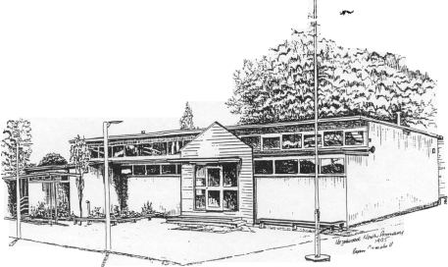

HAZELWOOD NORTH PRIMARY SCHOOL
HOMEWORK POLICY

Rationale:

Homework can benefit students by complementing classroom learning, fostering good study habits and providing an opportunity for students to be responsible for their own learning. Homework or Previewing is seen as a beneficial activity when directly related to classroom learning. It enables parents/guardians to develop an awareness of classroom practice and expectations and allows them to be actively involved in their child’s learning.

Aims:

- To enable parents to play an active role in the child’s learning and understand what is taking place at school
- To encourage children to take responsibility for on-going learning
- To develop, reinforce and practise skills to support classroom learning
- To develop the child’s organisational and time management skills
- To establish a home study routine

Implementation:

- The school’s homework policy will be distributed to parents at the commencement of each school year.
- At the beginning of each year each team will decide on the homework/preview guidelines for each area. These guidelines will be approved by the Principal before being sent home to parents to notify them of homework expectations.
- Classroom or specialist teachers will set homework/preview appropriate to each child’s skill level and age if the teachers deems it appropriate and/or needed.
- Teachers will prepare homework/preview as required that suits the needs of individual children within their classes.
- Each set task must be purposeful, meaningful and relevant to the current classroom curriculum. It should also be interesting, challenging and when appropriate open ended.
- Parents should ensure that Homework is balanced with a range of recreational, family and cultural activities.

Early Years (Prep – Year 3)

Homework/Preview will consist mainly of:
- daily reading to, with, and by parents/carer or older siblings
- mathematics activities
- simple extension tasks associated with classroom activities.
- gathering of additional information or materials

Homework will generally not exceed 30 minutes per day and will not be set on weekends or during vacation periods.

Upper Years (Years 4 – 6)

Homework will consist mainly of:
- independent reading on a daily basis
- tasks such as continuation of classroom work, projects and assignments, essays and research

- Homework will generally not exceed 30 minutes per day, must be coordinated between teachers to avoid excessive workload, and may be set during weekends and school vacations.
- It is acceptable for teachers to assign unfinished classroom activities as homework tasks.

Types of homework/preview activities that may be set include:

Practice exercises
Provide opportunities for students to apply new knowledge or to review, revise and reinforce newly acquired skills, such as:

- reading for pleasure
- practising spelling words
- practising physical education skills
- writing essays and other creative tasks
- practising and playing musical instruments
- completing consolidation exercises for Mathematics
- practising words/phrases learnt in a Language Other Than English.

Preview/Preparatory homework
Provides opportunities for students to gain background information so they are better prepared for future lessons, such as:

- collecting newspaper articles
- researching topics for class work
- reading background material for History
- reading English texts for class discussion
- revising information about a current topic.

Extension assignments
Encourage students to pursue knowledge individually and imaginatively, such as:

- writing a book review
- researching local news
- finding material on the Internet
- making or designing an art work
- monitoring advertising in a newspaper
- completing Science investigation exercises

Helping students
Parents and carers can help students with their homework by:

- encouraging a regular daily session to examine and complete homework
- discussing key questions or suggesting resources to help with homework
- helping to balance the time spent between homework and recreational activities
- asking how homework and class work is progressing, and acknowledging success
- attending the school events, productions or displays their child is involved in
- talking to teachers about any homework problems
- checking if homework has been set
- reading texts set by teachers
- discussing their child’s responses to set texts and asking to see their completed work
- linking homework and other learning activities to the families’ culture, history and language.

Evaluation:
This policy will be reviewed as part of the school’s review cycle.

This policy was last ratified by School Council in October 2014

To be reviewed September 2016

